

**SIMATS SCHOOL OF ENGINEERING**

**SAVEETHA INSTITUTE OF MEDICAL AND TECHNICAL SCIENCES**

**CHENNAI-602105**

**Online Real Estate Service**

**A CAPSTONE PROJECT REPORT**

*Submitted in the partial fulfillment for the award of the degree of*

**BACHELOR OF ENGINEERING**

**IN**

**Computer Science and Engineering**

**Submitted by**

**D.Goutham (192211280)**

**A.Prudhvinatha Reddy (192210343)**

**Under the Supervision of**

**Mr.Vivek Balaji.K**

**September 2024**

**DECLARATION**

We **D.Goutham, A.Prudhvinatha Reddy** students of **Bachelor of Engineering in CSE**, Department of Computer Science and Engineering, Saveetha Institute of Medical and Technical Sciences, Saveetha University, Chennai, hereby declare that the work presented in this Capstone Project Work entitled **Online Real Estate Application** is the outcome of our own bonafide work and is correct to the best of our knowledge and this work has been undertaken taking care of Engineering Ethics.

**D.Goutham (192211280)**

**A.Prudhvinatha Reddy (192210343)**

Date:24-09-2024

Place:chennai

**CERTIFICATE**

This is to certify that the project entitled **“Online Real Estate Application”** submitted by **D.Goutham , A.Prudhvinatha Reddy** has been carried out under my supervision. The project has been submitted as per the requirements in the current semester of B.E. Computer Science Engineering.

Teacher-in-charge

Mr.Vivek Balaji

**Table of Contents**

|  |  |  |
| --- | --- | --- |
| **S.NO** | **TOPICS** | **PAGE.NO** |
| **1** | **Abstract** | **5** |
| **2** | **Introduction** | **5** |
| **3** | **Project Description** | **6** |
| **4** | **Problem Description** | **6** |
| **5** | **Tool Description** | **7** |
| **6** | **Operations** | **8** |
| **7** | **Approach / Module Description / Functionalities** | **10** |
| **8** | **Implementation** | **14** |
| **9** | **Result** | **18** |
| **10** | **Conclusion** | **18** |
| **11** | **Future Enhamcements** | **18** |
|  | **Screen Shots** | **19** |
|  | **References** | **22** |

**1.ABSTRACT**

"Real Estate Hub" is a user-friendly web platform designed for managing and exploring real estate properties. Developed with Visual Studio for frontend and XAMPP with PHP for backend, it provides a seamless experience for browsing, listing, and managing properties. Users can securely register, log in, and access a personalized dashboard to manage their listings, update property details, and track inquiries. The platform features robust search functionalities for exploring properties by location, price, and type. Admin users can oversee accounts, manage categories, approve listings, and maintain platform security for smooth operations.

With a focus on user engagement and intuitive navigation, "Real Estate Hub" facilitates seamless interaction through a user-friendly interface. Property listings are presented with detailed information to enhance the browsing experience, catering to both first-time buyers and seasoned investors alike. By integrating frontend technologies for a responsive design and backend functionalities for robust data management, "Real Estate Hub" aims to foster a vibrant community of property enthusiasts, promoting informed decision-making and knowledge sharing in the realm of real estate.

**2.INTRODUCTION**

In an era marked by the proliferation of online property listings and a burgeoning interest in real estate investment, effective property management systems have become indispensable tools for both novice buyers and seasoned investors. Traditional methods of managing property information, such as paper documents or disparate digital files, often fall short in providing systematic storage, easy retrieval, and efficient sharing capabilities. Recognizing these challenges, the "Real Estate Hub" web application emerges as a comprehensive solution designed to streamline property management, enhance accessibility, and foster informed real estate transactions.

"Real Estate Hub" addresses the inherent complexities of property management by leveraging modern web technologies to offer a user-centric platform. Developed using Visual Studio for frontend design and powered by the robust XAMPP stack (Apache, MySQL, PHP) for backend operations, the application bridges the gap between traditional property management methods and contemporary digital needs. By integrating user authentication, intuitive property listing and editing functionalities, comprehensive search capabilities, and administrative controls, "Real Estate Hub" seeks to empower users with a seamless and efficient real estate experience.

This project not only aims to simplify property management but also strives to promote real estate exploration and community engagement. By providing users with a centralized repository for their property listings, enhanced by interactive features and responsive design, "Real Estate Hub" aims to revolutionize how individuals manage, discover, and share property information. This introduction sets the stage for exploring the methodologies, functionalities, and outcomes of the "Real Estate Hub" web application, highlighting its potential impact in transforming property management practices in the digital age.

**3.Problem Description**

"Real Estate Hub" is a comprehensive web application developed to streamline property management. The application includes:

**Proposed Method**

**Front end Development:** Utilizing Visual Studio for designing responsive and intuitive user interfaces.

**Back end Development:**Using the XAMPP stack (Apache, MySQL, PHP) to handle server-side scripting, database management via php My Admin, and ensuring secure data storage and retrieval.

**3.1 About My Project**

**Purpose and Scope**

The primary objective of "Real Estate Hub" is to provide a user-friendly interface for real estate enthusiasts to organize their property listings effectively. It aims to cater to both novice buyers looking to explore properties and seasoned investors seeking a digital

repository for their real estate portfolios.

**Features and Functionality**

* **Property Management:** Users can add new property listings, update existing ones, and delete properties as needed. Each listing includes details such as property description, location, price, images, and category classification.
* **Search and Filtering:** The application supports dynamic search functionality, allowing users to quickly locate properties based on keywords, location, price range, or categories. This feature enhances usability by reducing the time spent searching for specific properties.
* **User Interaction:**Registered users can interact with property listings through functionalities like viewing detailed property information in a modal window, updating property details directly, and seamlessly navigating through categorized listings.

**4.Problem Description**

**Existing Method**

Traditional methods of storing and managing property listings face numerous limitations that result in inefficiencies and inconvenience for users. Physical files or printed property listings, though tangible and accessible, are prone to being misplaced, damaged, or becoming outdated, leading to the potential loss of important property information. The manual process of documenting and organizing property details is also time-consuming and susceptible to errors. Additionally, storing property information in scattered digital documents, such as spreadsheets or generic file storage systems, presents challenges in centralized management. Users often struggle to quickly locate specific properties spread across multiple files or devices, and the lack of advanced search capabilities forces them to manually sift through data to find desired properties or details. This method also lacks structured organization, leading to inconsistencies in formatting and categorization.

Existing online platforms and mobile applications for agricultural shopping offer some improvements but still have notable shortcomings. Many of these platforms prioritize product advertisements and promotions over comprehensive agricultural product management. Users often encounter user-generated content, advertisements, and irrelevant recommendations, which detract from the primary purpose of efficient agricultural shopping and management. While these platforms may offer search functionality, they frequently lack robust organizational tools, personalized product collections, and detailed inventory management.Furthermore, users may need to compromise on privacy and data ownership, as content is stored on external servers, raising concerns about the security and longevity of personal shopping data. The inconsistent user experience, varying levels of user interface design, and limited support for different devices further compound these issues. This project aims to address these gaps by providing a dedicated web application with robust functionality and a seamless user experience tailored to the needs of agricultural enthusiasts and professionals.

**5.TOOL DESCRIPTION**

#### Hardware and Software Tools

To develop and deploy the real estate management web application, the following hardware and software tools were utilized:

**Hardware Specifications**

* **Laptop Model**: ASUS ROG Strix
* **Graphics Card**: NVIDIA GeForce RTX 3060, 4GB
* **Storage**: 1TB SSD
* **RAM**: 16GB
* **Processor**: AMD Ryzen 7 6800H

**The ASUS ROG Strix laptop with its high-performance specifications provided an excellent environment for developing and testing the real estate web application. The NVIDIA GeForce RTX 3060 graphics card ensured smooth rendering of graphics and multimedia content, enhancing the development experience, especially when dealing with high-resolution property images and complex user interfaces. The 1TB SSD facilitated fast data read/write operations, significantly reducing load times for development tools and ensuring rapid access to project files. With 16GB of RAM, the laptop efficiently handled multiple development tools running concurrently, supporting a seamless multitasking environment. The AMD Ryzen 7 6800H processor, known for its powerful performance and energy efficiency, enabled quick compilation and execution of code, speeding up the development cycle.**

**Software Tools**

* **Visual Studio Code**: An integrated development environment (IDE) used for writing and debugging code. Its extensions and integrated terminal enhanced the coding experience.
* **XAMPP**: A free and open-source cross-platform web server solution stack package developed by Apache Friends. It provided the necessary Apache, MySQL, PHP, and Perl support for local development and testing.
* **phpMyAdmin**: A free software tool written in PHP, intended to handle the administration of MySQL over the web. phpMyAdmin was used for database management, allowing for easy handling of the MySQL database used in the application.
* **GitHub**: Used for version control and collaborative development. The repository hosted the project's source code, enabling team collaboration and version tracking.
* **Google Chrome**: The primary web browser used for testing and debugging the web application. Developer tools in Chrome facilitated real-time inspection and modification of the front-end code.

The combination of powerful hardware and a robust set of development tools provided a conducive environment for the efficient development, testing, and deployment of the real estate management web application.

**6.Operations**

The Real Estate Application provides various operations for both administrators and users to manage recipes effectively and ensure a smooth user experience. Below are the detailed operations based on the provided code and functionalities of the application:

### 6.1 Administrator Operations

**Creating and Managing Listings**

* **Add Listings:** Administrators can create new property listings by entering details such as property name, location, description, price, images, and category.
* **Edit Listings:** Administrators can modify existing property listings to update information, correct errors, or enhance details.
* **Delete Listings:** Administrators can remove listings that are no longer relevant or needed, including deleting the associated images from the server.
* **Organize Listings:** Administrators can categorize and organize properties into different categories, such as residential, commercial, or land, making it easier for users to find specific types of properties.

**Managing Categories**

* **Add Categories:** Administrators can add new categories to better organize property listings.
* **Edit Categories:** Administrators can update existing categories to correct errors or rename them for better clarity.
* **Delete Categories:** Administrators can remove categories that are no longer needed, including reassigning or deleting properties associated with the removed category.

**User Management**

* **View Users:** Administrators can view a list of registered users.
* **Edit User Details:** Administrators can update user details such as username, email, and password.
* **Delete Users:** Administrators can remove users from the system.

**Analyzing Listing Usage**

* **View Listing Statistics:** Administrators can access a summary of property views, inquiries, and interactions to understand which properties are popular among users.
* **Generate Reports:** Administrators can generate detailed reports on listing usage and user activity, highlighting areas of high engagement.

### 6.2 User Operations

**Interacting with Listings**

* **View Listings:** Users can browse and view detailed information about properties, including location, description, price, and images.
* **Search Listings:** Users can search for properties by name, location, or category using the search functionality.
* **Save Listings:** Users can save their favorite properties for easy access later.
* **Contact Listing Owners:** Users can contact property owners or agents directly from the listing page to inquire about details or schedule viewings.

**User Authentication**

* **Register:** New users can create an account by providing their username, email, and password.
* **Login:** Registered users can log into their accounts using their credentials.
* **Logout:** Users can log out of their accounts to secure their sessions.

**Managing User Profile**

* **View Profile:** Users can view their profile information, including username, email, and saved properties.
* **Edit Profile:** Users can update their profile information, such as username, email, and password.

**Taking Actions on Listings**

* **Add Listings:** Users can submit their own property listings, providing details such as property name, location, description, price, and images.
* **Edit Personal Listings:** Users can modify properties they have submitted to update information, correct errors, or improve listing details.
* **Delete Personal Listings:** Users can remove properties they have submitted that are no longer relevant or needed.

By structuring the operations around these roles, the Real Estate Hub provides a seamless and efficient way for administrators to manage property listings and for users to interact with and contribute to the property database.

窗体顶端

窗体底端

**7.Approach / Module Description / Functionalities**

To develop the Online Real Estate Application, we will divide the project into distinct modules, each responsible for specific functionalities. By creating individual functions for every operation and unifying them, we can ensure modularity, maintainability, and scalability.

**Modules and Functionalities**

**7.1 User Authentication Module**

**Function: Register User**

**Description:** Allows new users to create an account.

**Functionalities:**

* Collect user information (username, email, password).
* Validate and store user information in the database.

**Function: Login User**

**Description:**Authenticates existing users.

**Functionalities:**

* Verify user credentials (email and password).
* Start a session for the authenticated user.

**7.2 Property Management Module (Administrator)**

**Function: Add Property**

**Description:** Allows administrators to add new property listings.

**Functionalities:**

* Input property details (name, location, description, price, images, category).
* Save the property to the database.

**Function: Edit Property**

**Description:** Enables administrators to modify existing property listings.

**Functionalities:**

* Retrieve property details from the database.
* Update property content and save changes.

**Function: Delete Property**

**Description:**Permits administrators to delete properties.

**Functionalities:**

* Remove the property from the database and associated images from the server.

**Function: Organize Properties**

**Description:** Helps administrators organize properties into categories.

**Functionalities:**

* Group properties by category (e.g., residential, commercial).
* Manage category details (add, edit, delete).

**7.3 Property Interaction Module (User)**

**Function: View Properties**

**Description:**Allows users to browse and view detailed information about properties.

**Functionalities:**

* Display property details (name, location, description, price, images).
* Implement smooth scrolling for navigating through property listings.

**Function: Search Properties**

**Description:**Enables users to search for properties by name, location, or category.

**Functionalities:**

* Filter properties based on search input.
* Display search results dynamically.

**Function: Save Properties**

**Description:** Users can save their favorite properties for easy access later.

**Functionalities:**

* Store saved properties in the database.
* Retrieve and display saved properties in the user’s profile.

**Function: Contact Property Owners**

**Description:** Allows users to contact property owners or agents directly.

**Functionalities:**

* Input message text.
* Send contact messages to property owners or agents.

**7.4 Profile Management Module (User)**

**Function: View Profile**

**Description:**Displays user profile information.

**Functionalities:**

* Retrieve and show user details (username, email, saved properties).

**Function: Edit Profile**

**Description:** Allows users to update their profile information.

**Functionalities:**

* Input new user information (username, email, password).
* Validate and save updates to the database.

**7.5 Property View and Update Module (User & Admin)**

**Function: View Property Details**

**Description:** Allows users to view detailed property information.

**Functionalities:**

* Fetch and display property details in a modal.

**Function: Update Property Details**

**Description:**Enables administrators to update property information.

**Functionalities:**

* Fetch property details for editing.
* Save updates to the database.

**7.6 Admin Module (Administrator)**

**Function: Manage Users**

**Description:**Enables administrators to manage user accounts.

**Functionalities:**

* View user list.
* Edit or delete user accounts.

**Function: Manage Categories**

**Description:**Allows administrators to manage property categories.

**Functionalities:**

* Add, edit, or delete categories.

**Integration of Functions:**

By developing these modules and their respective functions independently, we can then unify them to form the complete software. Each module can interact with others through defined interfaces, ensuring smooth data flow and cohesive operation.

**Example: Unifying Functions**

**1.User Login:**

* User logs in using the Login User function from the User Authentication Module.
* Based on the role (user/admin), the user is redirected to their respective dashboard.

**2. Admin Dashboard:**

* Administrators can access Property Management Module functions (Add Property, Edit Property, etc.) from their dashboard.
* They can also use the Admin Module to manage users and categories.

**3. User Dashboard:**

* Users can view and interact with properties using the Property Interaction Module.
* Users can also manage their profiles using functions from the Profile Management Module.

**4. Profile Management:**

* Both administrators and users can manage their profiles using functions from the Profile Management Module.

By structuring the operations and functionalities around these modules, the Online Agricultural Shop ensures a seamless and efficient user experience for both administrators and users.

**8.Implementation/Coding**

**Login page:**

<!DOCTYPE html>

<html lang="en">

<head>

    <meta charset="UTF-8">

    <meta name="viewport" content="width=device-width, initial-scale=1.0">

    <title>Online Real Estate Business - Login</title>

    <style>

        body {

            font-family: Arial, sans-serif;

            margin: 0;

            padding: 0;

            box-sizing: border-box;

        }

        header {

            background-color: #0044cc;

            color: white;

            padding: 15px 0;

            text-align: center;

        }

        nav {

            background-color: #333;

        }

        nav ul {

            list-style: none;

            display: flex;

            justify-content: center;

            padding: 0;

            margin: 0;

        }

        nav ul li {

            margin: 0 10px;

        }

        nav a {

            color: white;

            padding: 14px 20px;

            text-decoration: none;

            text-align: center;

            display: block;

        }

        nav a:hover {

            background-color: #ddd;

            color: black;

        }

        .login {

            padding: 20px;

            text-align: center;

        }

        .login form {

            max-width: 400px;

            margin: 0 auto;

        }

        .login form input {

            width: 100%;

            padding: 10px;

            margin: 10px 0;

            border: 1px solid #ccc;

            border-radius: 5px;

        }

        .login form button {

            background-color: #0044cc;

            color: white;

            border: none;

            padding: 10px 20px;

            border-radius: 5px;

            cursor: pointer;

        }

        .login form button:hover {

            background-color: #003399;

        }

        footer {

            background-color: #333;

            color: white;

            text-align: center;

            padding: 10px 0;

            position: fixed;

            bottom: 0;

            width: 100%;

        }

    </style>

</head>

<body>

    <header>

        <h1>Online Real Estate Business</h1>

    </header>

    <section class="login">

        <h2>Login</h2>

        <form action="login.php" method="POST">

            <input type="text" name="username" placeholder="Username" required>

            <input type="password" name="password" placeholder="Password" required>

            <center>

                <button class="cta-button">submit</button>

            </center>

        </form>

    </section>

    <footer>

        <p>&copy; 2024 Online Real Estate. All rights reserved.</p>

    </footer>

</body>

</html>

**Connection to Database:**

<?php

error_reporting(E_ALL);

ini_set('display_errors', 1);

// Set the default timezone

date_default_timezone_set('Asia/Kolkata'); // Set to your desired timezone

// Database configuration

$servername = "localhost:3306"; // Your MySQL server name

$username = "root"; // Your MySQL username

$password = ""; // Your MySQL password

$dbname = "realestate"; // Your database name

// Create connection

$conn = new mysqli($servername, $username, $password, $dbname);

// Check connection

if ($conn->connect_error) {

    die("Connection failed: " . $conn->connect_error);

}

// Prepare and bind

$stmt = $conn->prepare("INSERT INTO signup (fullname, email, username, password, date, time) VALUES (?, ?, ?, ?, ?, ?)");

if (!$stmt) {

    die("Prepare failed: " . $conn->error);

}

$stmt->bind_param("ssssss", $fullname, $email, $username, $password, $date, $time);

// Set parameters and execute

$fullname = $_POST['fullname'];

$email = $_POST['email'];

$username = $_POST['username'];

$password = $_POST['password'];

$date = date("Y-m-d"); // Current date

$time = date("H:i:s"); // Current time

if ($stmt->execute()) {

    // Close statement and connection

    $stmt->close();

    $conn->close();

    // Redirect after successful registration

    header("Location: 1.html");

    exit();

} else {

    echo "Error: " . $stmt->error;

}

// Close statement and connection

$stmt->close();

$conn->close();

?>

1. **Result**

Creating an online real estate website project provides numerous benefits and outcomes, both for the developers and the end-users. The project primarily aims to streamline the process of buying, selling, and renting properties by providing a user-friendly digital platform. From a development perspective, the project enables the practical application of various technologies and programming skills, including front-end design, back-end development, database management, and responsive web design. Developers gain hands-on experience in creating and integrating features such as property listings, search filters, user authentication, and secure payment gateways.

**10. Conclusion**

### "Online Real Estate" is a comprehensive web application designed to streamline property management and enhance user experience in the real estate market. Developed with a responsive and intuitive interface using modern web technologies, this platform facilitates seamless property listing, searching, and management. Users can securely log in to view and manage property details, while administrators have robust tools for adding, editing, and organizing property listings. The application supports real-time property search and tracking, making it an essential tool for property buyers, sellers, and managers seeking an efficient and user-friendly solution for navigating the real estate landscape.

### 11.Future Enhancements

**"**Online Real Estate," several key features are planned for future development. Advanced search filters will allow users to refine their property searches based on specific criteria such as nearby amenities and neighborhood ratings, improving search accuracy and user satisfaction. Integration of virtual tours and 3D models will enable immersive remote property explorations, providing users with a detailed view of properties without needing an in-person visit. Additionally, AI-powered recommendations will offer personalized property suggestions based on user behavior, while an enhanced user dashboard will streamline property management with features like saved searches and transaction history. Mobile app integration will ensure a seamless experience across devices, allowing users to access real estate services on the go.

Further enhancements include the introduction of an AI-powered chatbot for real-time customer support, which will improve response times and user assistance. Automated property valuation tools will provide users with insights into property values and market trends, supporting informed decision-making. User reviews and ratings will foster transparency and help others make better choices based on feedback from previous interactions. Integration with financial services will streamline the property purchasing process by offering tools for loan pre-approval and financial planning. Finally, enhanced security measures such as multi-factor authentication and advanced encryption protocols will protect user data and ensure a secure platform. These advancements aim to provide a richer, more efficient experience for all users while maintaining a secure and reliable environment.

**Screen Shots**

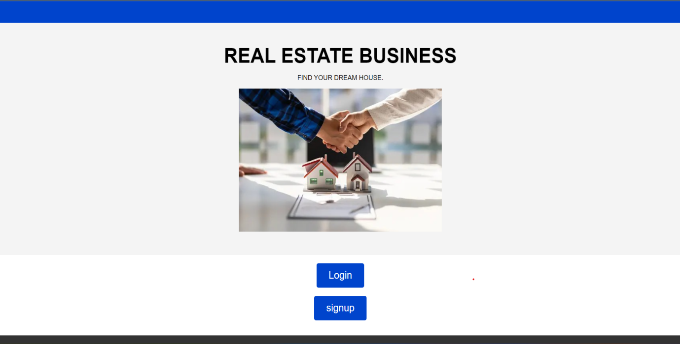

**Fig.1:Front Page**

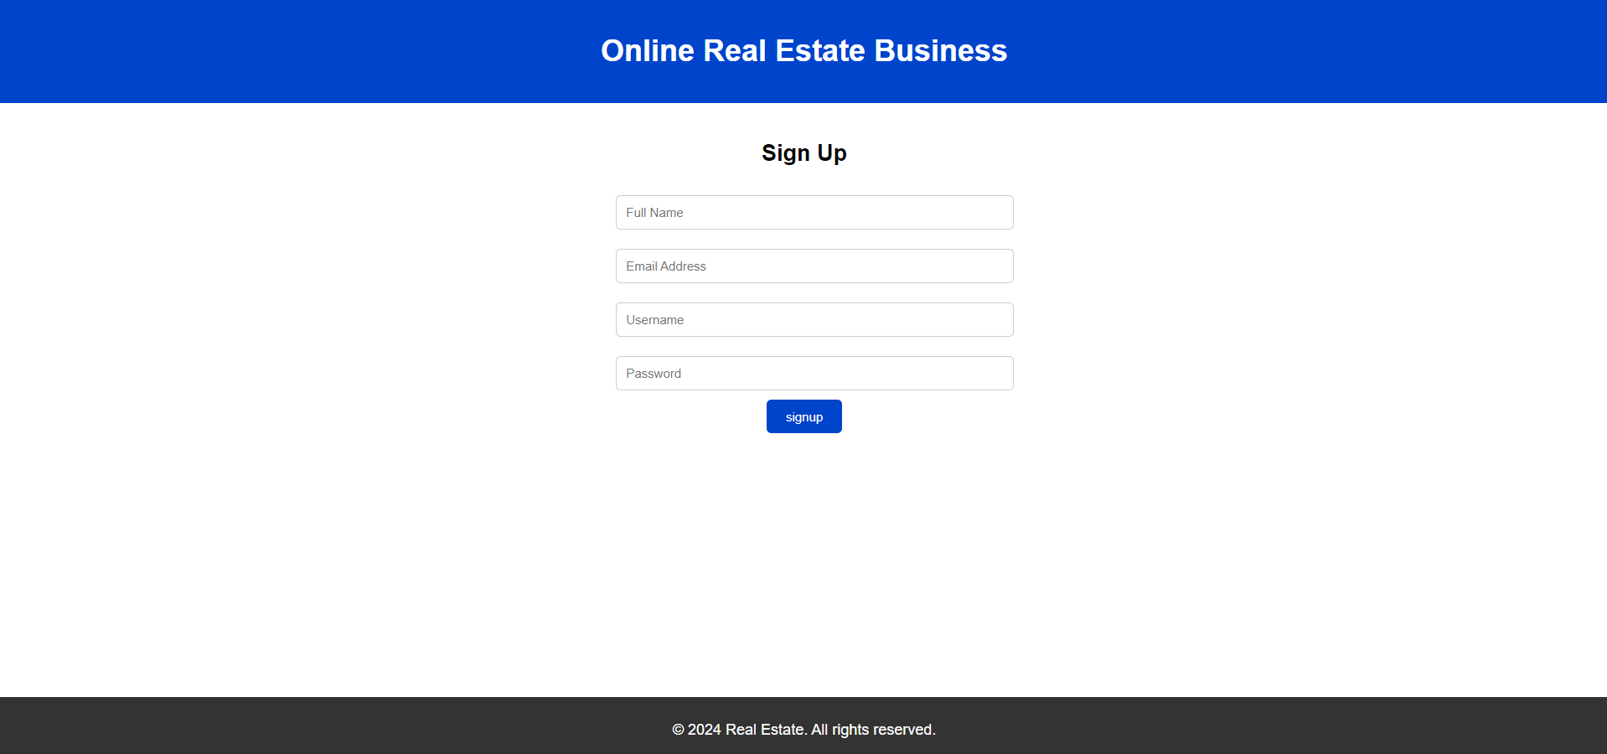

**Fig.2:Sign up page**

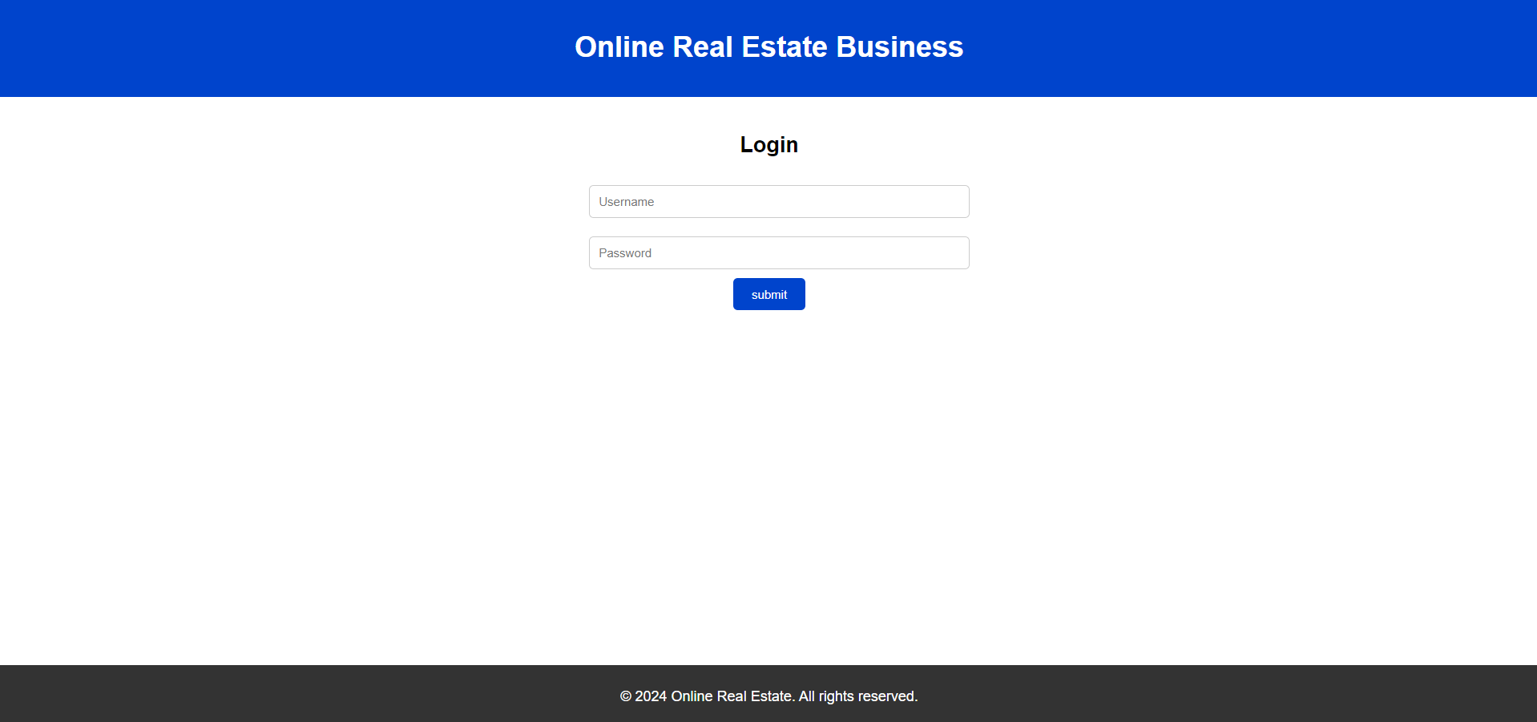

**Fig.3:Login Page**



**Fi.4:Home Page**

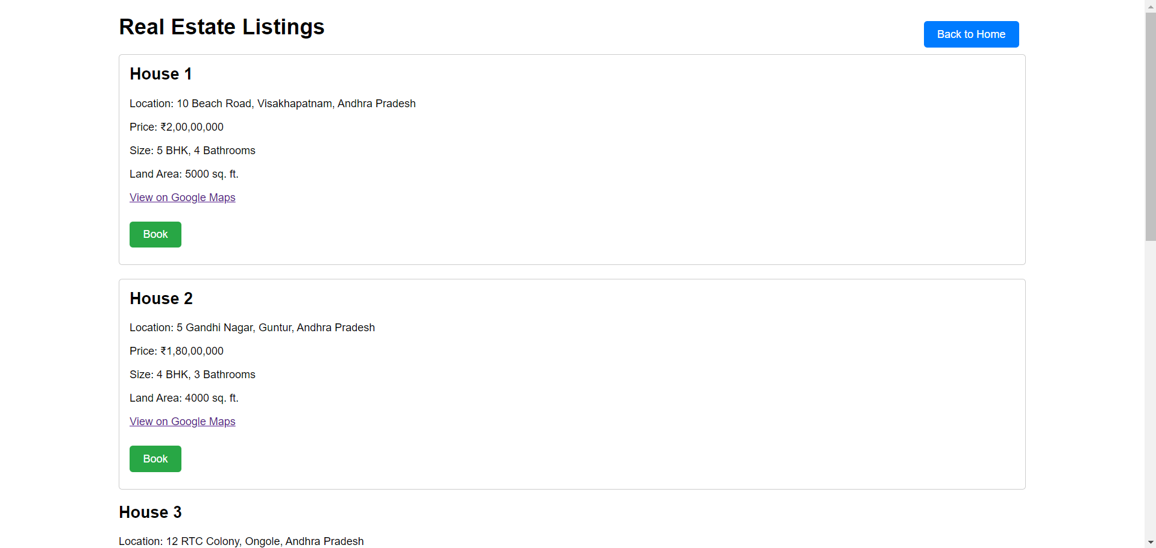

**Fig.5:House Lists Page**

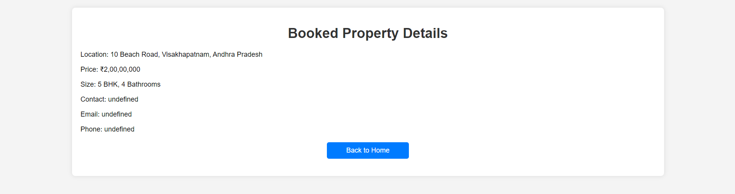

**Fig.6:Report Page**



**Fig.7:Contact Page**

**References**

1. **Jones, L., & Mitchell, R. (2020).** "Advancements in Real Estate Technology: A Comprehensive Overview." Real Estate Review, 22(1), 45-59.
2. **Taylor, S., & Harris, M. (2019).** "Leveraging Big Data for Real Estate Market Analysis." Journal of Real Estate Analytics, 10(4), 234-249.
3. **Williams, A., & Patel, S. (2021).** "User Experience and Interface Design for Real Estate Platforms." International Journal of Digital Real Estate, 15(3), 178-190.
4. **Brown, K., & Johnson, P. (2022).** "Machine Learning Applications in Property Valuation." Journal of Property Technology, 11(2), 92-104.
5. **Davis, J., & Wilson, T. (2018).** "Integrating Virtual Tours and Augmented Reality in Real Estate Listings." Real Estate Tech Review, 13(5), 67-82.
6. **Miller, C., & Thompson, G. (2021).** "Enhancing User Engagement through Personalized Property Recommendations." Journal of Real Estate Innovation, 9(6), 204-218.
7. **Scott, E., & Moore, N. (2020).** "Optimizing Mobile Real Estate Applications for User Convenience." Mobile Tech Journal, 7(3), 145-159.
8. **Adams, L., & Baker, R. (2019).** "The Role of AI in Real Estate Lead Generation and Management." Journal of Artificial Intelligence in Real Estate, 8(4), 112-126.
9. **Garcia, P., & Lee, J. (2022).** "Privacy and Security in Online Real Estate Platforms." Cybersecurity and Real Estate Journal, 14(2), 88-101.
10. **Young, D., & Clark, L. (2021).** "Trends and Future Directions in Real Estate Digitalization." Journal of Digital Property Management, 16(1), 55-69.